**Faculty of Engineering**

**Department of Electrical and Electronic Engineering**



**Analysis of a Micro-Grid power system in Solitaire, Namibia using HOMER Pro**

AUTHORS : Santhosh Kanaga Sabapathy Waqir Yusuf Zanhar

ID : 20006005

20025662

LECTURER : Dr. Kamyar Mehranzamir

DATE : 16/12/2019

**Contents**

**Abstract 3**

**Introduction 4**

**Literature Review 5**

**Methodology 7**

**Modelling and System Components 8**

**Load Consumption 9**

**System simulation with HOMER 11**

**Results and Discussion 14**

**Conclusion 22**

**References 23**

# Abstract

This paper is written for the study of micro-grid design and analysis conducted at a rural village near to Windhoek in Namibia, Africa. The methodology followed to design and examine the micro-grid system was by using HOMER pro software. The hybrid system has been designed with suitable wind turbine generator, diesel generator and solar panel as components of local micro grid supply system. The design aimed mainly to create an isolated micro grid system used to supply a specific load groups in a reliable and cost-effective electric power used for the rural village under the study. The design is prepared mainly by considering the present daily average load profiles for each house in the village.

The necessity of studying such a system is since most rural villages in Namibia are not directly connected to the already existing electric supply network. Most rural village homes which don’t have access to the National electric supply network usually use diesel generator set or car batteries as a standard power sources for meeting their basic household electric power supply demand. Analysis through Homer indicates that Hybrid power supply system which uses two or more power sources will give better and reliable power source with high cost effectiveness.

# Introduction

Natural gas, coal and unprocessed oil are currently the world’s main sources of energy. Coal and natural gas were the most used energy fuels for generating electricity. However, population growth and technology development resulted in dependency on these exhaustible energies were perceived to be not relevant to meet the upcoming global energy demand. In demand to develop a recyclable environment, it is in need to make water, heat and electricity independence using renewable energy as an energy source. The current study is aimed for a workable eco-friendly energy. The Site selection for the hybrid micro-grid design and analysis study is decided to be a rural village which is 223 km from the capital city Windhoek in Namibia, Africa.

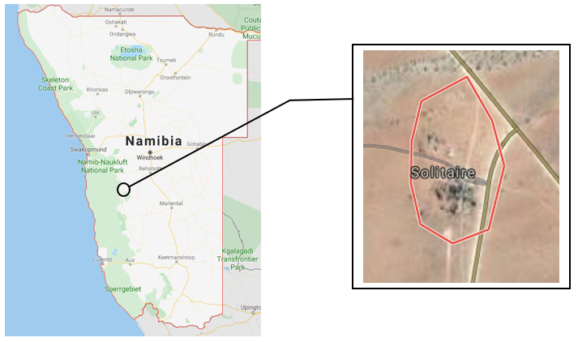

Figure 1: Map of Solitaire, Namibia

In a hybrid energy system, the electrical power demand must be met by using various systems such as electrical generator and storage devices working together. Normally, a combination of renewable energy such as solar energy, wind energy, and geothermal with the common conventional sources such as fuels (diesel generator) with support from the battery storage are used for power generation and are connected to the national grid whenever applicable. Because of its difficulty in its design, hybrid solar system composed by two or more energy sources must be designed and sized to reduce the risk of failure in its operation.

The main aim is to design, and conduct evaluation of isolated hybrid Micro-Grid Power supply method using HOMER pro software and check the reliability and cost effectiveness of the system. The hybrid system has been designed with appropriate wind turbine generator, diesel generator and solar panel as components of local micro grid supply system. This design includes battery storage as an electric power storage technology into the system.

# Literature Review

About five hundred million people in Africa had no electricity, and seven hundred million people live without clean cooking facilities that weren’t clean, in 2010 [1].

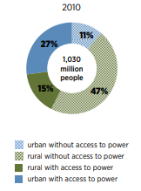

Figure 2: Power Access in rural and urban Africa (2010)

From Figure 2 it is easily visible that 47% of the population residing in rural areas can’t access to electricity and the necessity of electricity in the world is increasing every day. Due to limited amount of fossil fuel, it is important to design a few renewable energy systems that can decrease dependence on conventional energy resources. Renewable sources are increasingly economically feasible providing a simple level of access to electricity.

50% of power generations in Namibia is produced locally and the rest is imports from Eskom in South Africa and by ZESCO in Zambia [2]. The challenge faced by Namibia is that the reliability of the power supply from the national electric grid is not good and there is a high rate of interruption of power. At the same time Namibia has very limited access to traditional generation technologies of coal fired, hydro or nuclear power. It is cheaper to import electricity from South Africa than coal to South Africa.

Hydro is limited cause Namibia is a very dry country. Namibia has a small skill base hence nuclear can’t be a good option in Namibia. Yet Namibia has some chances. Africa is one of the sunniest countries in the world. Figure 3 shows the global irradiation level in Sub-Saharan Africa. “The distribution of solar resources across Africa is fairly uniform, with more than 85% of the continent's landscape receiving at least 2,000 kWh / (m² year)” [3]. Solar isn’t the only opportunity Africa is gifted with, Africa has a large seashore, where wind power resources are ample and unutilized in the north and south.

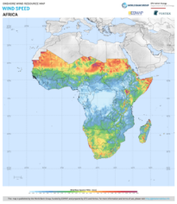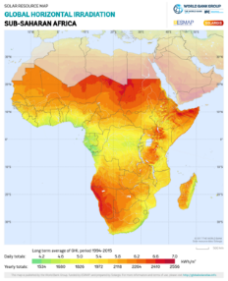

Figure 4: Wind Speed in Sub-Saharan Africa

Figure 3: Global Horizontal Irradiation in Sub-Saharan Africa

Namibia is also known by its high solar radiation intensity approximately 6.2 kWh/m2 to 7.0 kWh/m2. And the wind speed ranging from 4.0m/s to 6.0m/s [3]. Using this information, a hybrid renewable energy system could be designed and used to decrease the need of conventional energy resources. For off grid locations solar PV systems and wind turbines can’t work on their own and are unable to work reliably and effectively due to the variability of the respective resources.

HOMER is a micro power optimization modelling software, that shortens the task of assessing designs of both off-grid and grid-connected power systems for a multitude of applications. The software is used to design and analyse hybrid power systems, which can contain a mix of solar PV cells, hydropower, batteries & fuel cells, biomass, conventional generators, wind turbines and other inputs [4]. In HOMER, we can analyse the costs including total net production cost, operational cost and maintenance cost and decide on the ideal design for the system[5].

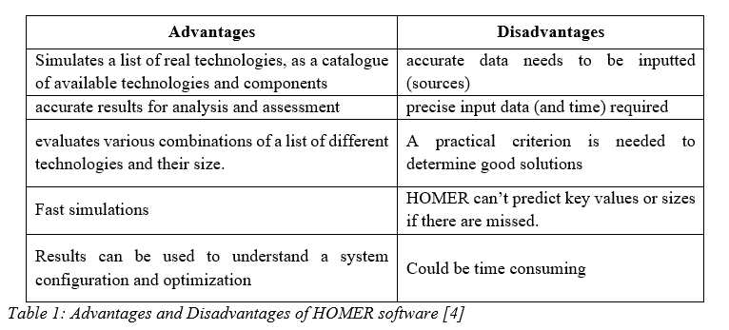

# Methodology

“HOMER software is a computer model developed by the U.S. National Renewable Energy Laboratory (NREL)” [6]. It is a tool that has been used in micro grid design optimisation. HOMER helps in planning, designing and navigating the complexities of building an affordable and reliable micro grid composed by the conventional and renewable power, storage and load management [7]. HOMER simulates the feasibility of the modelled system, giving the levelized cost of energy (LCOE) and net present cost (NPC) as the measurement parameters [6].

In this study, HOMER Pro has been extensively used for the system renewability study [8]. Figure 5 shows the homepage of the HOMER Pro summarising the information on system architecture, economic and location.

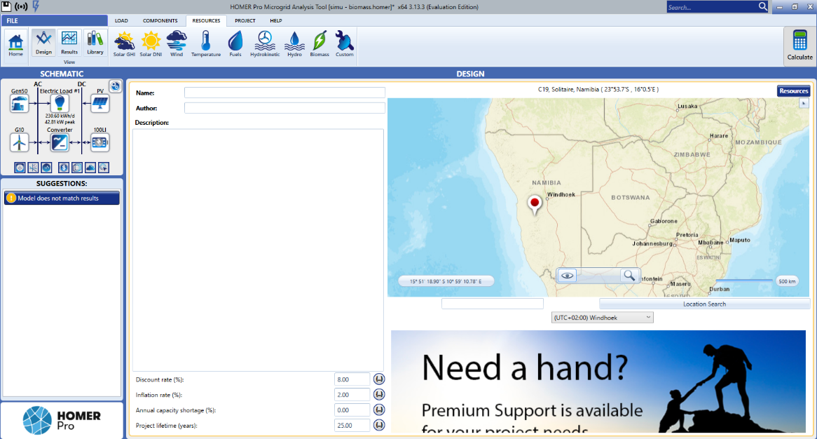

Figure 5: Main page of Homer Pro with Solitaire selected

HOMER Pro requires several inputs in simulating the modelled system. Those include the items listed in Table 2. In general, HOMER Pro executes a few vital tasks; simulation, optimisation, and analysis.

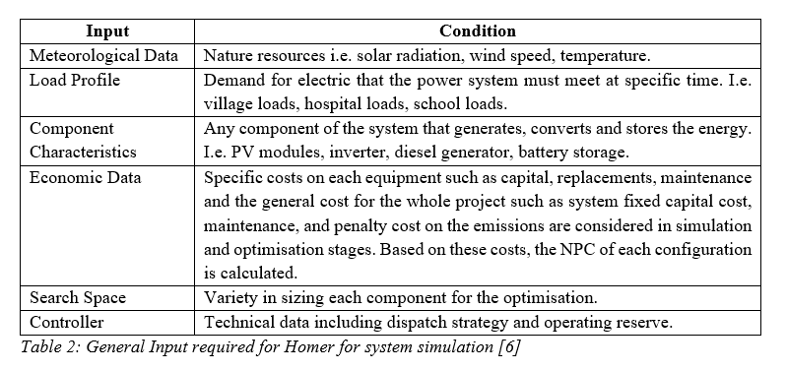

# Modelling and System Components

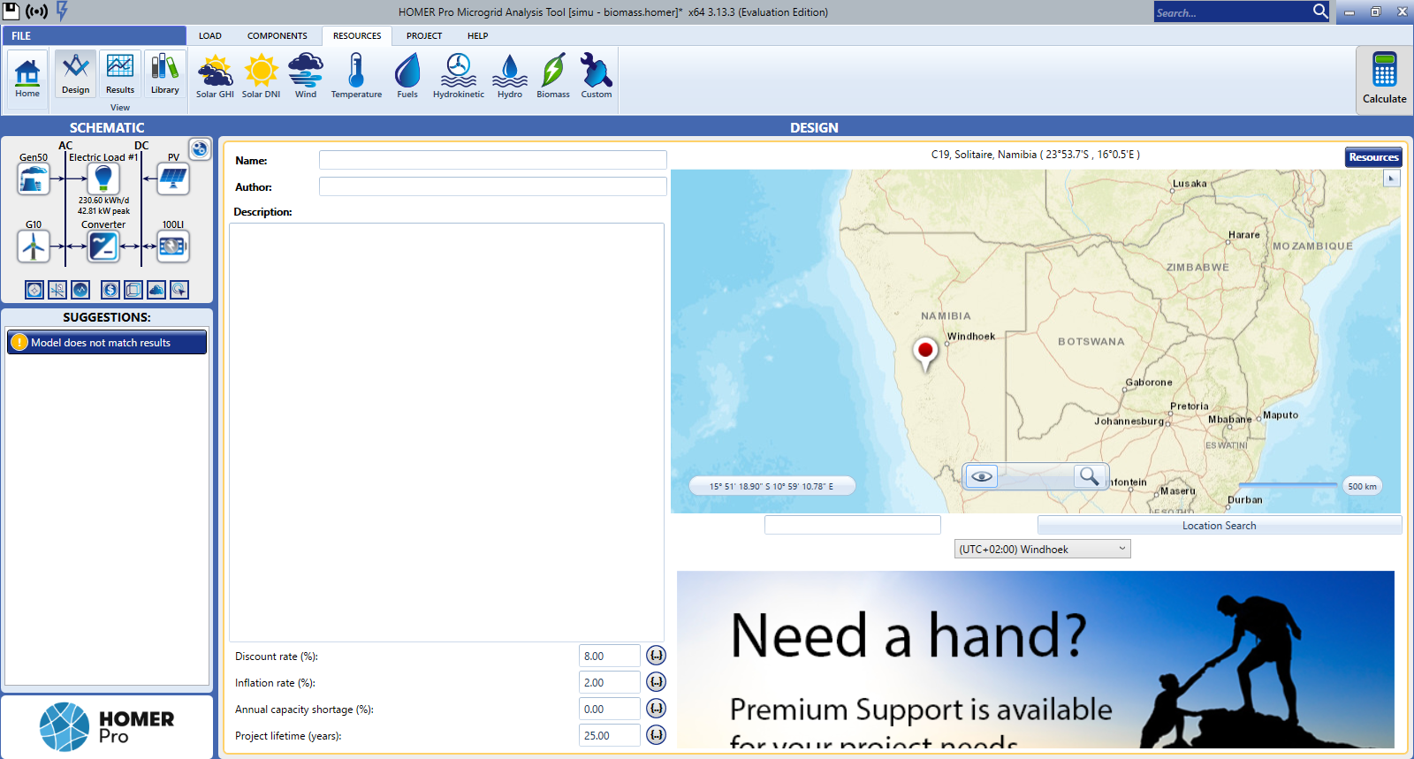

Figure 6: General Schematic of the system

|  |  |  |
| --- | --- | --- |
| Logo | Name | Description |
|  | Generator  Generic 50kW Fixed Capacity Generator | The only conventional way of producing power in this system by using diesel. |
|  | Load Required | This is the total load required for all the households combined. |
|  | PV  Generic Flat Plate PV | Renewable form of power received directly through the sun. |
|  | Wind Turbine  Generic 10kW | Renewable form of power, received through the wind. |
|  | Convertor  System Convertor | This is required to convert DC to AC or back.  To store AC power into a battery it needs to be converted to a DC supply.  Power received through PV is in DC, thus, it must be converted to AC before it’s sent to households. |
|  | Storage  Generic 100kW Li-ion | Used to store excess power generated by system |

Table 3: Description of individual components in the system

# Load Consumption

In this section, the load consumption for this case study was evaluated assuming the common appliances in each house. Solitaire is a small settlement in the Khomas Region of central Namibia. This remote settlement is located at the edge of the Namib-Naukluft National Park. In this case study, Solitaire is assumed to have 20 households, each with 2 bedrooms, 1 bathroom, 1 living room, and 1 kitchen. Each household is assumed to have similar appliances and hours of usage per day is estimated for each appliance. A total of 6 appliances were considered, such as, fans, air conditioners, LED lights, a fridge, a television and an internet router.

As shown in table 1 below, the total load in watts is determined, along with the energy in kWh. The scaled annual average energy required is given to be 230.6kwh/d with an average power of 18.7kw. This scaled annual average energy value is for 20 houses and is used as the electric load in Homer Pro. The total power calculated, is vital in determining the sizing of generator and renewable components. Moreover, the day-to-day random variability is set to 10% and the random variability time step is set to 20%.

|  |  |  |  |  |  |  |  |  |
| --- | --- | --- | --- | --- | --- | --- | --- | --- |
| **LOAD CONSUMPTION** | | | | | | | | |
| **APPLIANCES** | **LOAD WATT (W)** | **QAUNTITY OF APPLIANCES PER HOUSE** | | | | **TOTAL POWER (W)** | **HOURS OF USE** | **kWh per HOUSE** |
| **BEDROOMS** | **LIVING ROOM** | **BATHROOM** | **KITCHEN** |
| **FAN** | 75 |  | 1 |  |  | 75 | 16 | 1.2 |
| **AC** | 318 | 2 |  |  |  | 636 | 10 | 6.36 |
| **LED LAMPS** | 5 | 2 | 2 | 1 | 1 | 30 | 14 | 0.42 |
| **FRIDGE** | 100 |  |  |  | 1 | 100 | 24 | 2.4 |
| **TV** | 79 |  | 1 |  |  | 79 | 10 | 0.79 |
| **INTERNET ROUTER** | 15 |  | 1 |  |  | 15 | 24 | 0.36 |
|  | | | | **TOTAL PER HOUSE** | | **935** |  | **11.53** |
| **NO. OF HOUSES** | | 20 | | |
| **TOTAL** | | 18700 |  | **230.6** |

Table 4: Load Consumption

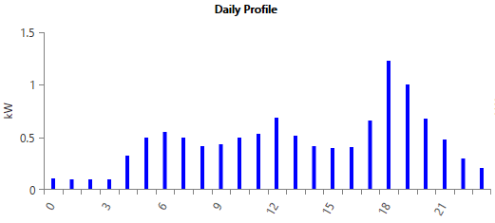

Figure 7: Power consumption per hour

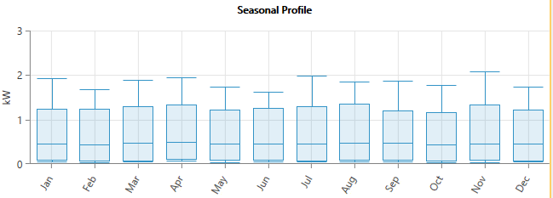

Figure 8: Monthly power usage

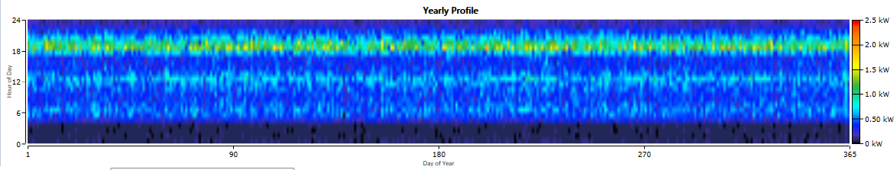

Figure 9: Yearly power usage

After the evaluated values are entered in the software, the daily, seasonal and yearly profiles are generated and are depicted in Figures 1, 2 and 3 respectively above.

Figure 1 above displays the power consumption (kW) at various times during a day. It shows that the peak power consumption is between 6 pm and 8 pm. Simlarly, figure 2 displays the monthly power usage across a year while figure 3 shows the power usage for 24 hours across 365 days. The peak power requirement is 42.81kW with a load factor of 0.22. All the loads are assumed to be AC loads.

# System simulation with HOMER

Initially, it is vital to locate Solitaire, Namibia in Homer Pro. This eases the search for any required data. After evaluating and inputting the load values to the electrical load, the remaining components are selected.

Firstly, a suitable generator is to be selected from a wide range of choices. To obtain the more optimum power system, 2 separate simulations were completed using diesel and biodiesel as the generator fuels. Each system contained the same components while differing in fuel type. For each fuel, the cost per liter was found and included in the respective system. While diesel cost $0.932/liter, biodiesel was more expensive at $2.29/liter. The generator chosen was the **Generic 50kW Fixed Capacity Genset.** Both systems were simulated with and without the generator, to compare the results.

Subsequently, a wind turbine of 10kW was selected for the system. For the turbine, sensitivity values were added to the hub height. The heights chosen were 25m and 30m. Under wind resources, the average wind speeds were downloaded from the NASA Surface Meteorology and Solar Energy database by Homer Pro. Figure 4 below shows the average wind speeds for the last 12 months. Moreover, it is vital to include the accurate value of altitude above sea level for Solitaire. Solitaire is located 1071m above sea level. The anemometer height must be relatively close to the hub height. Thus, it was set at 25m.

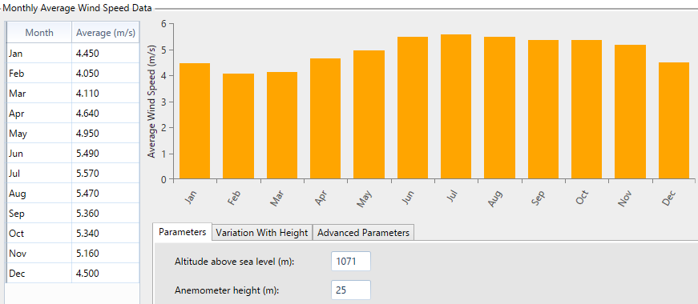

Figure 10: Wind Resource Data for Solitaire, Namibia

Following this, a PV panel was to be selected to harvest solar energy. As mentioned earlier, a generic flat plate PV was selected. The derating factor was set at 80% while the lifetime was 15 years. The rated capacity was 120kW. The Homer optimizer was selected to ensure that the optimum system is determined automatically.

Under the solar global horizontal irradiance (GHI) tab, the scaled annual average irradiance data were downloaded from the NASA Surface Meteorology and Solar Energy database by Homer Pro. This included the daily radiation values per month and the clearness index per month. This is shown in figure 5 below. Also, it provides the scaled annual average which is 6.15 kWh/m2/day. The graph in figure 5 indicates the trends for clearness index and radiation.

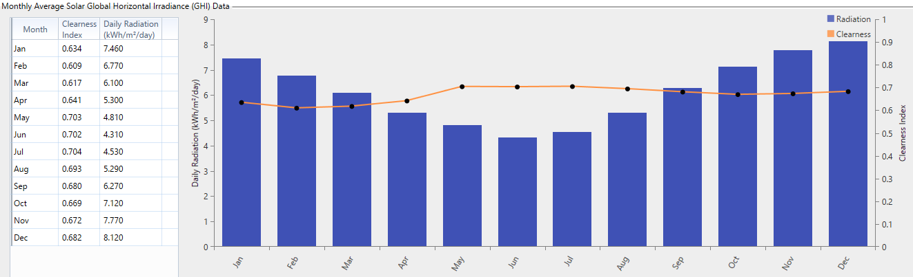

Figure 11: Solar GHI

Furthermore, it is also important to insert the average temperatures, for a more optimum system. This is because temperatures affect the efficiency of PV panels. This data is also downloaded by Homer Pro. Figure 6 below shows the average temperature values per month while the scaled annual average is 21.02℃.

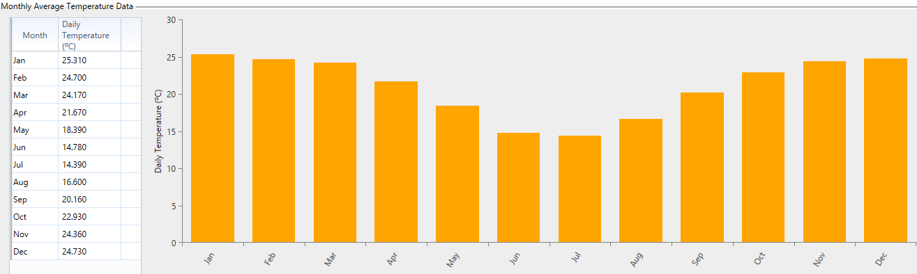

Figure 12: Average Temperature Data

Although, installation of the PV flat plate looks simple, it’s important to remember that the PV system produces DC. Therefore, a **Convertor** is important. A system convertor is selected with a 95% efficiency and a lifetime of 15 years. It is connected in parallel to the system generator. The convertor is required to change the DC produced by PV panel to AC for supply to households. Moreover, it is also needed to store the excess power produced by the generator and wind turbine. The excess power is stored in a DC battery. However, the generator and wind turbine produce AC. To change AC to DC for storage, a convertor is vital.

Finally, a battery is required to store the excess energy. The excess energy is stored to power households during breakdowns in the system. Homer Pro has a wide range of batteries available for selection. For this system, a generic 100kWh Li-Ion battery was picked.

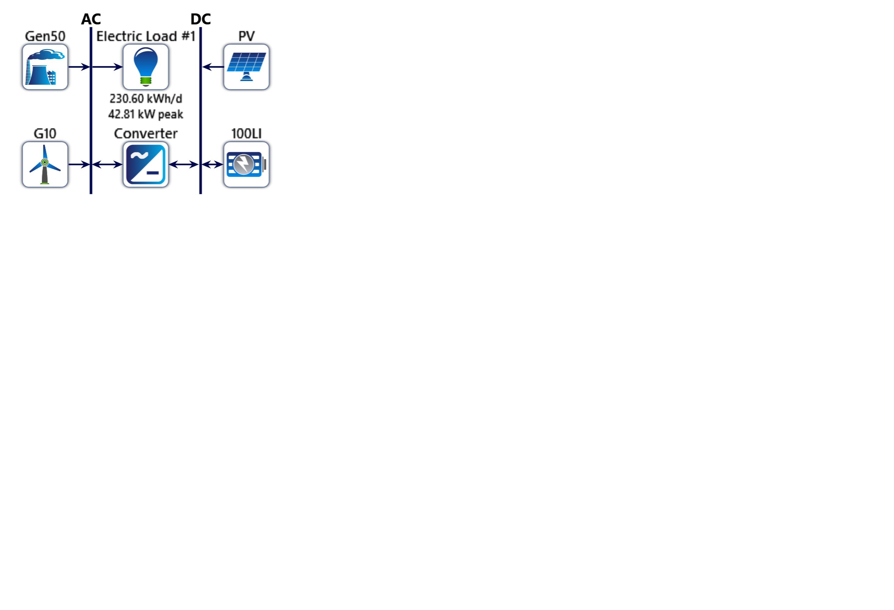

Figure 13: System Schematic

For all components in the system, the Homer Pro optimizer was selected. This allows Homer to simulate to determine the ideal number of batteries and wind turbines required along with the optimum power required for the PV panels and the convertor for the system to supply the required load. Figure 7 above shows the system design and its components which is implemented in both simulations using diesel and biodiesel as fuels for the generator.

# Results and Discussion

**Diesel Generator**

The generator included in the designed system which included PV and wind turbines, uses diesel as the fuel. Diesel in Namibia costs $0.932/L, which is quite cheap. However, diesel is non-renewable with high amounts of greenhouse gases emitted during combustion. The Homer optimizer was used in the system to determine the best system configuration. The wind turbine hub heights had sensitivity values of 25m and 30m.

Overall, 11,671 solutions were simulated, of which, 8,545 were feasible. The simulated results showed that the optimum result doesn’t include the 10kW wind turbine. In fact, it proves that PV panel and the diesel generator alone can handle the load. Thus, the hub height doesn’t matter.

On further inspection of simulation results that considered a 30m hub height, it is quite clearly visible that the wind turbine is an unnecessary cost.

System Design

|  |  |  |  |
| --- | --- | --- | --- |
| Component | Name | Size | Unit |
| Generator | Generic 50kW Fixed Capacity Genset | 50.0 | kW |
| PV | Generic flat plate PV | 46.1 | kW |
| Storage | Generic 100kWh Li-Ion | 2 | strings |
| System converter | System Converter | 26.6 | kW |
| Dispatch strategy | HOMER Load Following |  |  |

Table 5: System Components

* Net Cost

|  |  |  |  |  |  |  |
| --- | --- | --- | --- | --- | --- | --- |
| Name Capital | | Operating | Replacement | Salvage | Resource | Total |
| Generic  100kWh  Li-Ion | $140,000 | $25,855 | $59,614 | -$10,942 | $0.00 | $214,527 |
| Generic 50kW  Fixed Capacity  Genset | $25,000 | $11,771 | $6,088 | -$5,919 | $50,669 | $87,609 |
| Generic flat plate PV | $115,243 | $5,959 | $48,894 | -$9,202 | $0.00 | $160,894 |
| System Converter | $7,979 | $0.00 | $3,385 | -$637.16 | $0.00 | $10,727 |
| System | $288,222 | $43,585 | $117,983 | -$26,701 | $50,669 | $473,758 |

Table 6: Net costs

Table 3 above shows the breakdown of costs for each component in the optimum system. This optimum system neglects wind turbine. When compared to the best system design that considers wind turbines, at hub height 30m, this optimum system is not only found to be cheaper, but it also has a greater renewability fraction.

Table 4 below shows a comparison of 2 systems, where the base case is the best system design that considers wind turbines. As seen in the table, the base case is more expensive than the optimum system. Even though, the initial capital is lower, the operating costs are greater for the base case. The amount of fuel consumed per year for the optimum system is less than half the amount of fuel required for the base case. Thus, the carbon dioxide emissions are higher.

|  |  |  |
| --- | --- | --- |
|  | **Base Case** | **Current System** |
| **Net Present Cost** | $504,234 | $473,758 |
| **Initial Capital** | $238,475 | $288,222 |
| **Operating cost** | $20,558 | $14,352 |
| **Cost of useful electrical energy produced (per kWh)** | $0.463 | $0.435 |
| **CO22 Emitted (kg/yr)** | 24,220 | 11,009 |
| **Fuel Consumption (L/yr)** | 9,252 | 4,205 |
| **Renewability Fraction (%)** | 70.6 | 86.1 |

Table 7: Compare Economics

However, a system incorporating both solar and wind is expected to have less CO2 emissions. But this depends on the system components. On further investigation, it is clearly visible in figure 8 that when wind turbine is incorporated, the solar power decreases. Moreover, the convertor power reduces along with the number of batteries while the generator remains same. Although, the generator capacity is the same, the power produced by it is different. As shown in figure 9, the generator included in the system with wind energy produces a greater power output, which requires more fuel. This is the reason why the renewability fraction is lower for the base case as it requires a greater generator output.

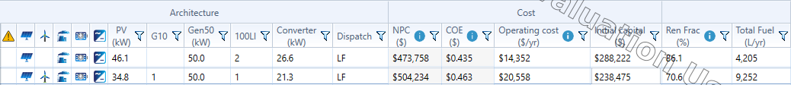

Figure 14: Comparison of components

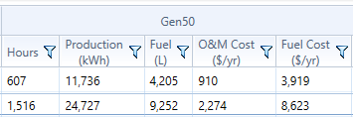

Figure 15: Generator usage

Therefore, the optimum system design includes only the PV and diesel generator.

* **summary**

|  |  |  |
| --- | --- | --- |
| Component | Production (kWh/yr) | Percent |
| Generic PV | **88,473** | **88.3** |
| Generic 50kW Fixed Capacity Genset | **11,736** | **11.7** |
| Total | **100,209** | **100** |

Table 16: Excess Table 17: Production Summary

|  |  |  |
| --- | --- | --- |
| Quantity | Value | Units |
| Excess Electricity | **7,967** | **kWh/yr** |
| Unmet Electric Load | **0** | **kWh/yr** |
| Capacity Shortage | **0** | **kWh/yr** |

Table 5 shows the amount of excess electricity produced in kWh/yr while table 6 displays the percentage of total power produced by the flat plate PV and Generator. The flat plate PV produces more than 88% of total power.

**Biodiesel Generator**

Unlike diesel, biodiesel has low amounts of greenhouse emissions. However, it is quite expensive compared to regular diesel and is priced at $2.29/L. Although the cost of the system would increase drastically as expected, the renewability fraction increases too and will usually be closer to 100%. The generator included in the designed system which included PV and wind turbines, uses biodiesel as the fuel. The wind turbine hub heights had sensitivity values of 25m and 30m.

Overall, 13,917 solutions were simulated, of which, 10,945 were feasible. Like the diesel generator system, the simulated results showed that the optimum result doesn’t include the 10kW wind turbine. Again, it proves that PV panel and the diesel generator alone can handle the load. Thus, the hub height doesn’t matter.

System Design

|  |  |  |  |
| --- | --- | --- | --- |
| Component | Name | Size | Unit |
| Generator | Generic 50kW Fixed Capacity Genset | 50.0 | kW |
| PV | Generic flat plate PV | 55.9 | kW |
| Storage | Generic 100kWh Li-Ion | 2 | strings |
| System converter | System Converter | 35.5 | kW |
| Dispatch strategy | HOMER Load Following |  |  |

Table 10: System Components

Comparing tables 2 & 7 shows that the biodiesel system requires a larger flat plate PV and a larger system converter.

* Net Cost

|  |  |  |  |  |  |  |
| --- | --- | --- | --- | --- | --- | --- |
| Name Capital | | Operating | Replacement | Salvage | Resource | Total |
| Generic  100kWh  Li-Ion | $140,000 | $25,855 | $67,277 | -$1,679 | $0.00 | $231,452 |
| Generic 50kW  Fixed Capacity  Genset | $25,000 | $7,000 | $0.00 | -$2,386 | $54,309 | $83,924 |
| Generic flat plate PV | $139,822 | $7,230 | $59,323 | -$11,165 | $0.00 | $195,209 |
| System Converter | $10,661 | $0.00 | $4,523 | -$851.34 | $0.00 | $14,333 |
| System | $315,483 | $40,085 | $131,123 | -$16,081 | $54,309 | $524,919 |

Table 11: Net Costs

Table 8 above shows the breakdown of costs for each component in the optimum system. Like the diesel system, this optimum system neglects wind turbine. When compared to the best system design that considers wind turbines, at hub height 30m, this optimum system is found to be cheaper. However, unlike the diesel generator system, the optimum system has a smaller renewability fraction.

|  |  |  |
| --- | --- | --- |
|  | Base Case | Current System |
| **Net Present Cost** | $557,951 | $524,919 |
| **Initial Capital** | $353,465 | $315,483 |
| **Operating cost** | $15,818 | $16,201 |
| **Cost of useful electrical energy produced (per kWh)** | $0.513 | $0.482 |
| **CO2 Emitted (kg/yr)** | 41.6 | 47.1 |
| **Fuel Consumption (L/yr)** | 1,621 | 1,835 |
| **Renewability Fraction (%)** | 95.2 | 94.6 |

Table 12: compare economics

Table 9 above shows a comparison of 2 systems, where the base case is the best system design that considers wind turbines. As seen in the table, the base case is more expensive than the optimum system. Even though, the initial capital is lower, the operating costs are greater for the optimum system. The amount of fuel consumed per year for the optimum system is more than the amount of fuel required for the base case. Thus, the carbon dioxide emissions are higher.

Identical to the diesel generator system, the optimum system design includes only the PV and diesel generator.

* **summary**

|  |  |
| --- | --- |
| Quantity | Value (kWh/yr) |
| Excess Electricity | 18,589 |
| Unmet Electric Load | 0 |
| Capacity Shortage | 0 |

|  |  |  |
| --- | --- | --- |
| Component | Production (kWh/yr) | Percent |
| Generic flat plate PV | 107,343 | 95.9 |
| Generic 50kW Fixed Capacity Genset | 4,538 | 4.06 |
| Total | 111,881 | 100 |

Table 13: Excess Table 14: Production Summary

Table 10 shows the amount of excess electricity produced in kWh/yr while table 11 displays the percentage of total power produced by the flat plate PV and Generator. The flat plate PV produces almost 96% of total power. The biodiesel system produces more than double the excess electricity produced by the diesel system. This increase cost drastically, as storage of this power requires more batteries.

However, there is an upside. This excess electricity in both systems allows further development of Solitaire over the years. The flat plate PV produces more overall power and is more efficient.

Although both simulations were successful, we can’t implement both. Both systems have their own pros and cons. The ideal system for solitaire depends on the condition. Should the system be the cheapest or the cleanest?

In a rural area, the project cost is very important. Thus, implementing the diesel generator system is the ideal solution. Although, it produces a lot more CO2, the system is cheaper and has enough excess electricity for further development of Solitaire. Another reason to consider the diesel generator system is the fact that currently, diesel is a lot cheaper than biodiesel in Namibia.

**Generator: Generic 50kW Fixed Capacity Genset (Diesel)**

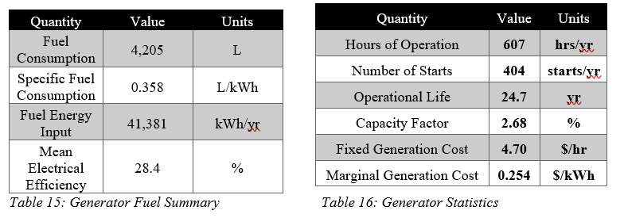

Table 15 shows the fuel consumption of diesel generator along with the efficiency and energy input. Table 16 specifies the general information like the operation hours, capacity factor and fixed generation cost.

**PV: Generic flat plate PV**

|  |  |  |
| --- | --- | --- |
| Quantity | Value | Units |
| Rated Capacity | **46.1** | **kW** |
| Mean Output | **10.1** | **kW** |
| Mean Output | **242** | **kWh/d** |
| Capacity Factor | **21.9** | **%** |
| Total Production | **88,473** | **kWh/yr** |

Table 17: PV Statistics

Table 17 displays the mean outputs in kW and kWh/day along with the capacity factor and rated capacity while showing the total production of 88,473 kWh/yr for the flat plate PV.

**Storage: Generic 100kWh Li-Ion**

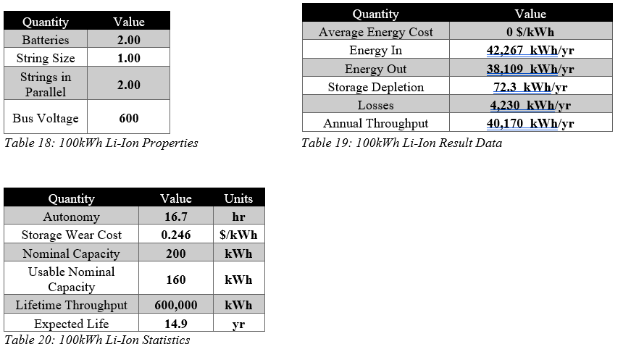

Tables 18, 19 and 20 are related to the Li-Ion battery which is used for storage.

**Converter: System Converter**

|  |  |
| --- | --- |
| Quantity | Value |
| Capacity | **26.6 kW** |
| Mean Output | **8.38 kW** |
| Minimum Output | **0 kW** |
| Maximum Output | **24.2 kW** |
| Capacity Factor | **31.5 %** |

|  |  |
| --- | --- |
| Quantity | Value |
| Hours of Operation | **8,354 hrs/yr** |
| Energy Out | **73,437 kW/yr** |
| Energy In | **77,303 kW/yr** |
| Losses | **3,865 kW/yr** |

Table 21: System Converter Statistics Table 22: System Converter Electrical Summary

Tables 21 and 22 are related to the system converter and show the max, min and mean output in addition to the operation hours and losses.

**Fuel Summary**

|  |  |  |
| --- | --- | --- |
| Quantity | Value | Units |
| Total fuel consumed | **4,205** | **L** |
| Avg fuel per day | **11.5** | **L/day** |
| Avg fuel per hour | **0.480** | **L/hour** |

Table 23

**Emissions**

|  |  |
| --- | --- |
| Pollutant | Quantity (kg/yr) |
| Carbon Dioxide | **11,009** |
| Carbon Monoxide | **68.7** |
| Unburned Hydrocarbons | **3.03** |
| Particulate Matter | **0.412** |
| Sulphur Dioxide | **27.0** |
| Nitrogen Oxides | **64.6** |

Table 24

Table 24 shows the quantity of greenhouse gases produced by burning diesel in the generator. According to the table, 11,009kg of CO2 is produced per year, which is rather large and harmful to earth.

**Renewable Summary**

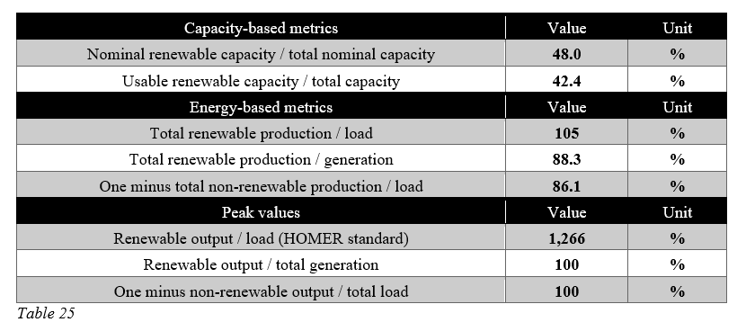

Table 25 shows the total renewable energy production divided by load, which is 105%. This means that an additional 5% energy is being produced, which can be stored in a battery.

# Conclusion

This study is about designing a hybrid renewable energy scheme for a rural village, Solitaire in Namibia, and using Homer Pro to simulate and optimize the system. The most optimum system is a combination of PV cell along with a generator fuelled by diesel. It can be concluded that it is one of the most efficient methods to power up a rural area like Solitaire, where the solar irradiance is quite high.

A wind turbine rated at 10kW was added to the system with a hub height of either 25m or 30m. However, Homer Pro simulated and proved that this would not be the ideal system needed for Solitaire. Similarly, the biodiesel system that was simulated was deemed too expensive compared to the cheaper diesel generator system. Moreover, the battery and convertor included in the system are vital in storing the excess energy produced. This could be used as back-up power during power cuts or breakdowns. Furthermore, the system that was designed and simulated, has enough capacity to increase the load and develop Solitaire in the future while using the available renewable resources and this system can be used to develop other rural areas in a similar manner.

# References

1. (IRENA), T.I.R.E.A., *Africa Renewable Future*. 2013.

2. ENERGY, M.O.M.A., *Namibia Electricity Supply Demand Options*. 2008.

3. J.E Hoffmann, E.P.D., *Integrating desalination with concentrating solar thermal power_ A&nbsp;Namibian case study _ Elsevier Enhanced Reader.* 2017.

4. K. E. Okedu, U.R., *Optimization of Renewable Energy Efficiency using HOMER.* 2014. **4**(2).

5. Pandey, K., P. Banerjee, and D. Mathur, *Study and Modelling of Green Energy based Micro-Grid for Rural Area.* Indian Journal of Science and Technology, 2016. **9**(21).

6. Halim, A., et al., *Feasibility Study on Hybrid Solar Photovoltaic with Diesel Generator and Battery Storage Design and Sizing Using HOMER Pro (R).* Jurnal Kejuruteraan, 2018. **1**(3): p. 69-76.

7. R. Srivastava, V.K.G., *Optimization of Hybrid Renewable Resources using HOMER* 2016. **6**(1).

8. Wondwossen A., C.P., *Design And Performance Analysis Of Hybrid*

*Micro-Grid Power Supply System Using Homer*

*Pro Software For Rural Village Near To*

*Kombolcha Town, Ethiopia.* 2019.